In this activity you will compare the rotation, dilation, and translation families. For each family you will transform a point (the independent variable) and describe the behavior of the transformed point (the dependent variable). Then you will compare the different families with each other.

Begin with a new sketch, and construct and observe each family on a different page of the sketch. For each family, follow the steps below.

Transform a Point

1. On a new page of the sketch, prepare any needed center, parameter, or vector.  
(a) For rotation, create center point *C* and angle parameter *θ*.  
(b) For dilation, create center point C and parameter *scale*.  
(c) For translation, construct a segment *AB* and mark it as the vector.

To name a parameter *θ*, type its label as {theta}, using curly brackets.

You can mark the center, parameter, and vector when you construct them, or you can mark them later by clicking them after you open the transformation dialog box*.*

2. Construct an independent point, label it, and transform it. Label the dependent variable using function notation to describe it—for example, *RC,θ*(*x*), or *DC,scale*(*y*), or *TAB*(*s*).

3. Turn on tracing for both variables.

**Q1** Drag the independent variable up and down, and describe the relative speed and direction of the dependent variable. Drag the independent variable right and left, and describe the relative motion of the dependent variable. Can you find any fixed points? If so, where are they?

4. Construct a polygon and restrict the domain of the independent variableto the polygon’s border.

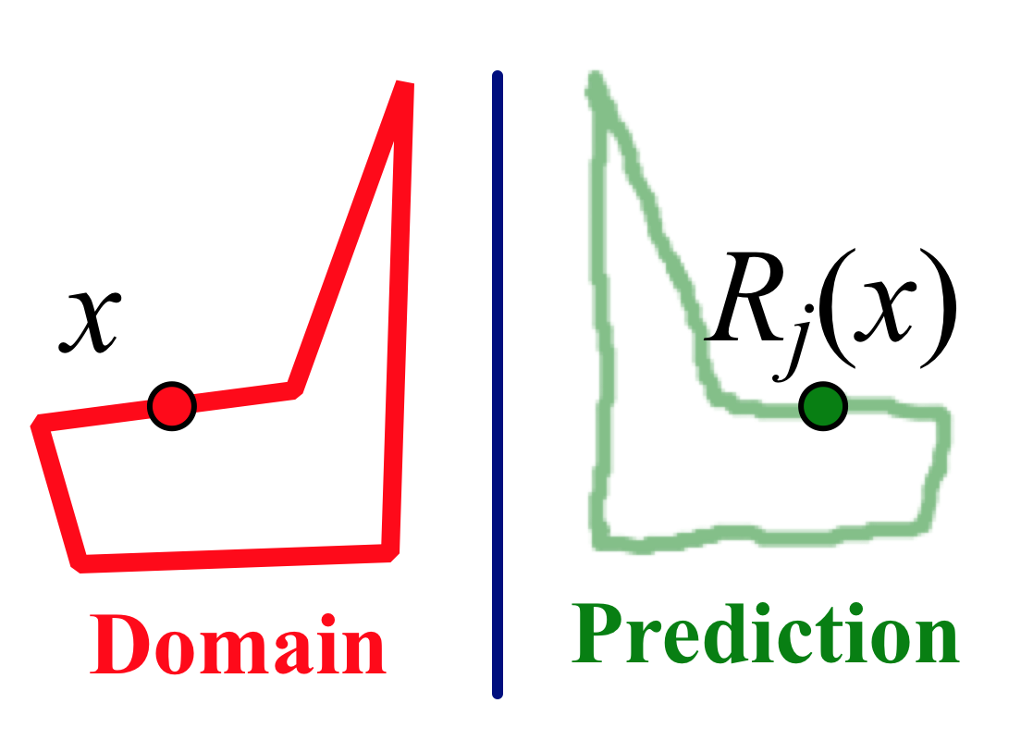5. Draw with the **Marker** tool to predict the path of the dependent variable. Then drag the independent variable along its domain, so that the dependent variable traces out the range.

**Q2** How did your prediction work out? Make a drawing on your paper to show how well you did.

6. Change the restricted domain by dragging the polygon vertices, erase the traces, and use the **Marker** tool to make a new prediction.

**Q3** How accurate was your second prediction? Make a drawing to show how you did.

**Q4** For this transformation, how are the range and domain similar, and how are they different? Consider position, size, angle, and anything else you think of.

**Q5** How do the shapes of the domain and range relate to your observations from Q1 about the relative speed and direction of the variables?

7. Construct a different member of the same family, using a different independent variable and a different angle, scale factor, or vector. Keep the same center point (if your transformation uses one). Restrict the function’s domain to the same polygon, and trace the dependent variable as you vary the independent variable.

**Q6** How does the range of the new function compare to the range of the original function? What is similar, and what is different, about these two functions?

**Q7** Fill in the table of Function Family Characteristics for this family.

Explore More

Explore the Glide Reflection family, and create a presentation sketch and a Family Characteristics table for this function*.* The Glide Reflection function is not built into Sketchpad, but you can create it by combining two other functions: a translation and a reflection, both using the same segment (as the vector and the mirror).

8. In a new sketch, construct independent variable *x* and segment *AB*. Mark points *A* and *B* as a vector for translation, and mark segment *AB* as a mirror.

9. Translate *x* and then reflect the translated image. Hide the translated image, and label the reflected point *GAB*(*x*) to stand for “glide reflection, using vector *AB*, of *x*.”

10. Drag point *x* and observe the behavior of its glide reflection. Investigate the relative speed and direction of the variables.

11. Construct a polygon and restrict the domain of *x* to the polygon. Trace the dependent variable to show the range, and compare domain and range.

12. Select *x* and *GAB*(*x*) and choose **Transform | Define Custom Transform.** Name the custom tranformation *Glide[AB].* This adds your glide reflection to the bottom of the Transform menu.

13. Select the transformed point *GAB*(*x*) and choose **Transform | Glide[AB].** With the transformed point still selected, choose **Transform | Glide[AB]** several more times. Drag point *x* to observe the result.

14. Turn on tracing for all the transformed points and drag again.

**Q8** Change your polygon and mirror, drag again, and draw. Create an interesting picture, and draw it on your paper.

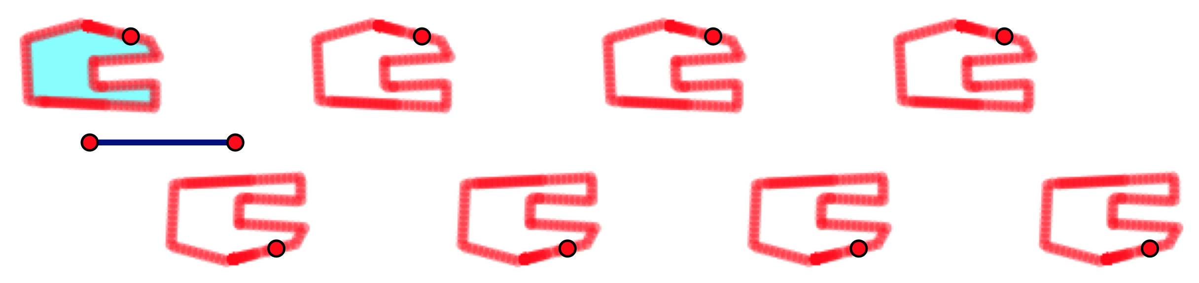

You can repeat any of the transformation functions in the same way. Try a 30° rotation function or a translation function to see what patterns they make.

**Function Family Characteristics**

|  |  |  |  |
| --- | --- | --- | --- |
| **Family Name:** | **Reflection** | | |
|  | **Function** | **Independent variable** | **Dependent variable** |
| *rj* | *x* | *rj* (*x*) |
| **Description:** | This function reflects across mirror *j.* | | |
| **Relative Speed:** | The independent and dependent variables move at the same speed. | | |
| **Relative Direction:** | When *x* moves parallel to the mirror, *rj*(*x*) moves in the same direction. When *x* moves perpendicular to the mirror, *rj*(*x*) moves in the opposite direction. | | |
| **Fixed Points:** | The fixed points are the points on the mirror. | | |
| **Shape:** |  | | |
| **Family Name:** |  | | |
| **Notation:** | **Function** | **Independent variable** | **Dependent variable** |
|  |  |  |
| **Description:** |  | | |
| **Relative Speed:** |  | | |
| **Relative Direction:** |  | | |
| **Fixed Points:** |  | | |
| **Shape:** |  | | |

**Function Family Characteristics**

|  |  |  |  |
| --- | --- | --- | --- |
| **Family Name:** |  | | |
| **Notation:** | **Function** | **Independent variable** | **Dependent variable** |
|  |  |  |
| **Description:** |  | | |
| **Relative Speed:** |  | | |
| **Relative Direction:** |  | | |
| **Fixed Points:** |  | | |
| **Shape:** |  | | |
| **Family Name:** |  | | |
| **Notation:** | **Function** | **Independent variable** | **Dependent variable** |
|  |  |  |
| **Description:** |  | | |
| **Relative Speed:** |  | | |
| **Relative Direction:** |  | | |
| **Fixed Points:** |  | | |
| **Shape:** |  | | |

Construction Hints

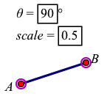 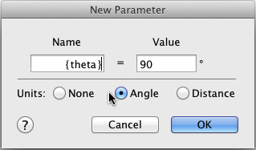1. To create angle parameter *θ*, choose **Number | Parameter**, click the **Angle** radio button to make it an angle parameter, and type its label using curly brackets like this: {theta}. To mark it as the angle, select the parameter and choose **Transform | Mark Angle.** To create and mark parameter *scale*, choose **Number | Parameter**, type its name, and set its value. Then choose **Transform | Mark Scale Factor.** To create and mark vector *AB*, use the **Segment** tool 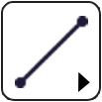 to make a segment and use the **Text** tool  to label its endpoints. Then select points *A* and *B* in order and choose **Transform | Mark Vector.**

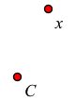 2. To construct *x*, use the **Point** tool , and then use the **Text** tool  to label it. For rotation and dilation you will also need a center point *C*. To mark *C* as the center of rotation, select it and choose **Transform | Mark Center.** (You don’t have to mark the center ahead of time; you can click it in the sketch once the Rotation or Dilation dialog box is open.)

3. If you switched to the **Text** tool or the **Segment** tool, be sure to choose the **Arrow** tool  before dragging.

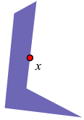 4. To construct a polygon, use the **Polygon** tool 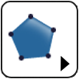. Finish the polygon by clicking on the first vertex again, or by double-clicking as you construct the last vertex. After constructing the polygon, you may want to hide its vertices: select them with the **Arrow** tool  and choose **Display | Hide Points.** To restrict the independent variable to the polygon, select both objects (the independent variable and the polygon) and choose **Edit | Merge Point to Polygon.** To turn on tracing the the dependent variable, select it and choose **Display | Trace Point.**

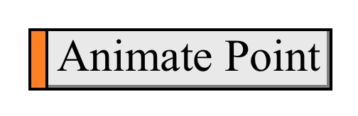 5. Instead of dragging, you can select the independent variable and choose **Display | Animate Point.** Or you can make an animation button by selecting *x* and choosing **Edit | Action Buttons | Animation.**

6. To construct a different member of the family, repeat the earlier directions for steps 1 through 3, using new parameters, a new center point, and a new independent variable. To avoid confusion, name these objects differently from the originals. When you reach step 4, merge your second independent variable to the same polygon you created earlier. This will make comparisons easier.

**Answer sheet for the ___________________________ function family**

1. Drag *x* up and down, and describe the relative speed and direction of the dependent variable. Drag *x* right and left, and describe the relative motion. Can you find any fixed points? If so, where are they?
2. How did your prediction work out? Make a drawing on your paper to show how you did.
3. How accurate was your second prediction? Make a drawing to show how you did.
4. For this transformation, how are the range and domain similar, and how are they different? Consider position, size, angle, and anything else you think of.
5. How do the shapes of the domain and range relate to your observations from Q1 about the relative speed and direction of the variables?
6. How does the range of the new function compare to the range of the original function? What is similar, and what is different, about these two functions?

**1.** What was the most interesting part of exploring the transformation families?

**2.** Describe one thing about these functions that you had trouble understanding, or that you’d like to investigate further.